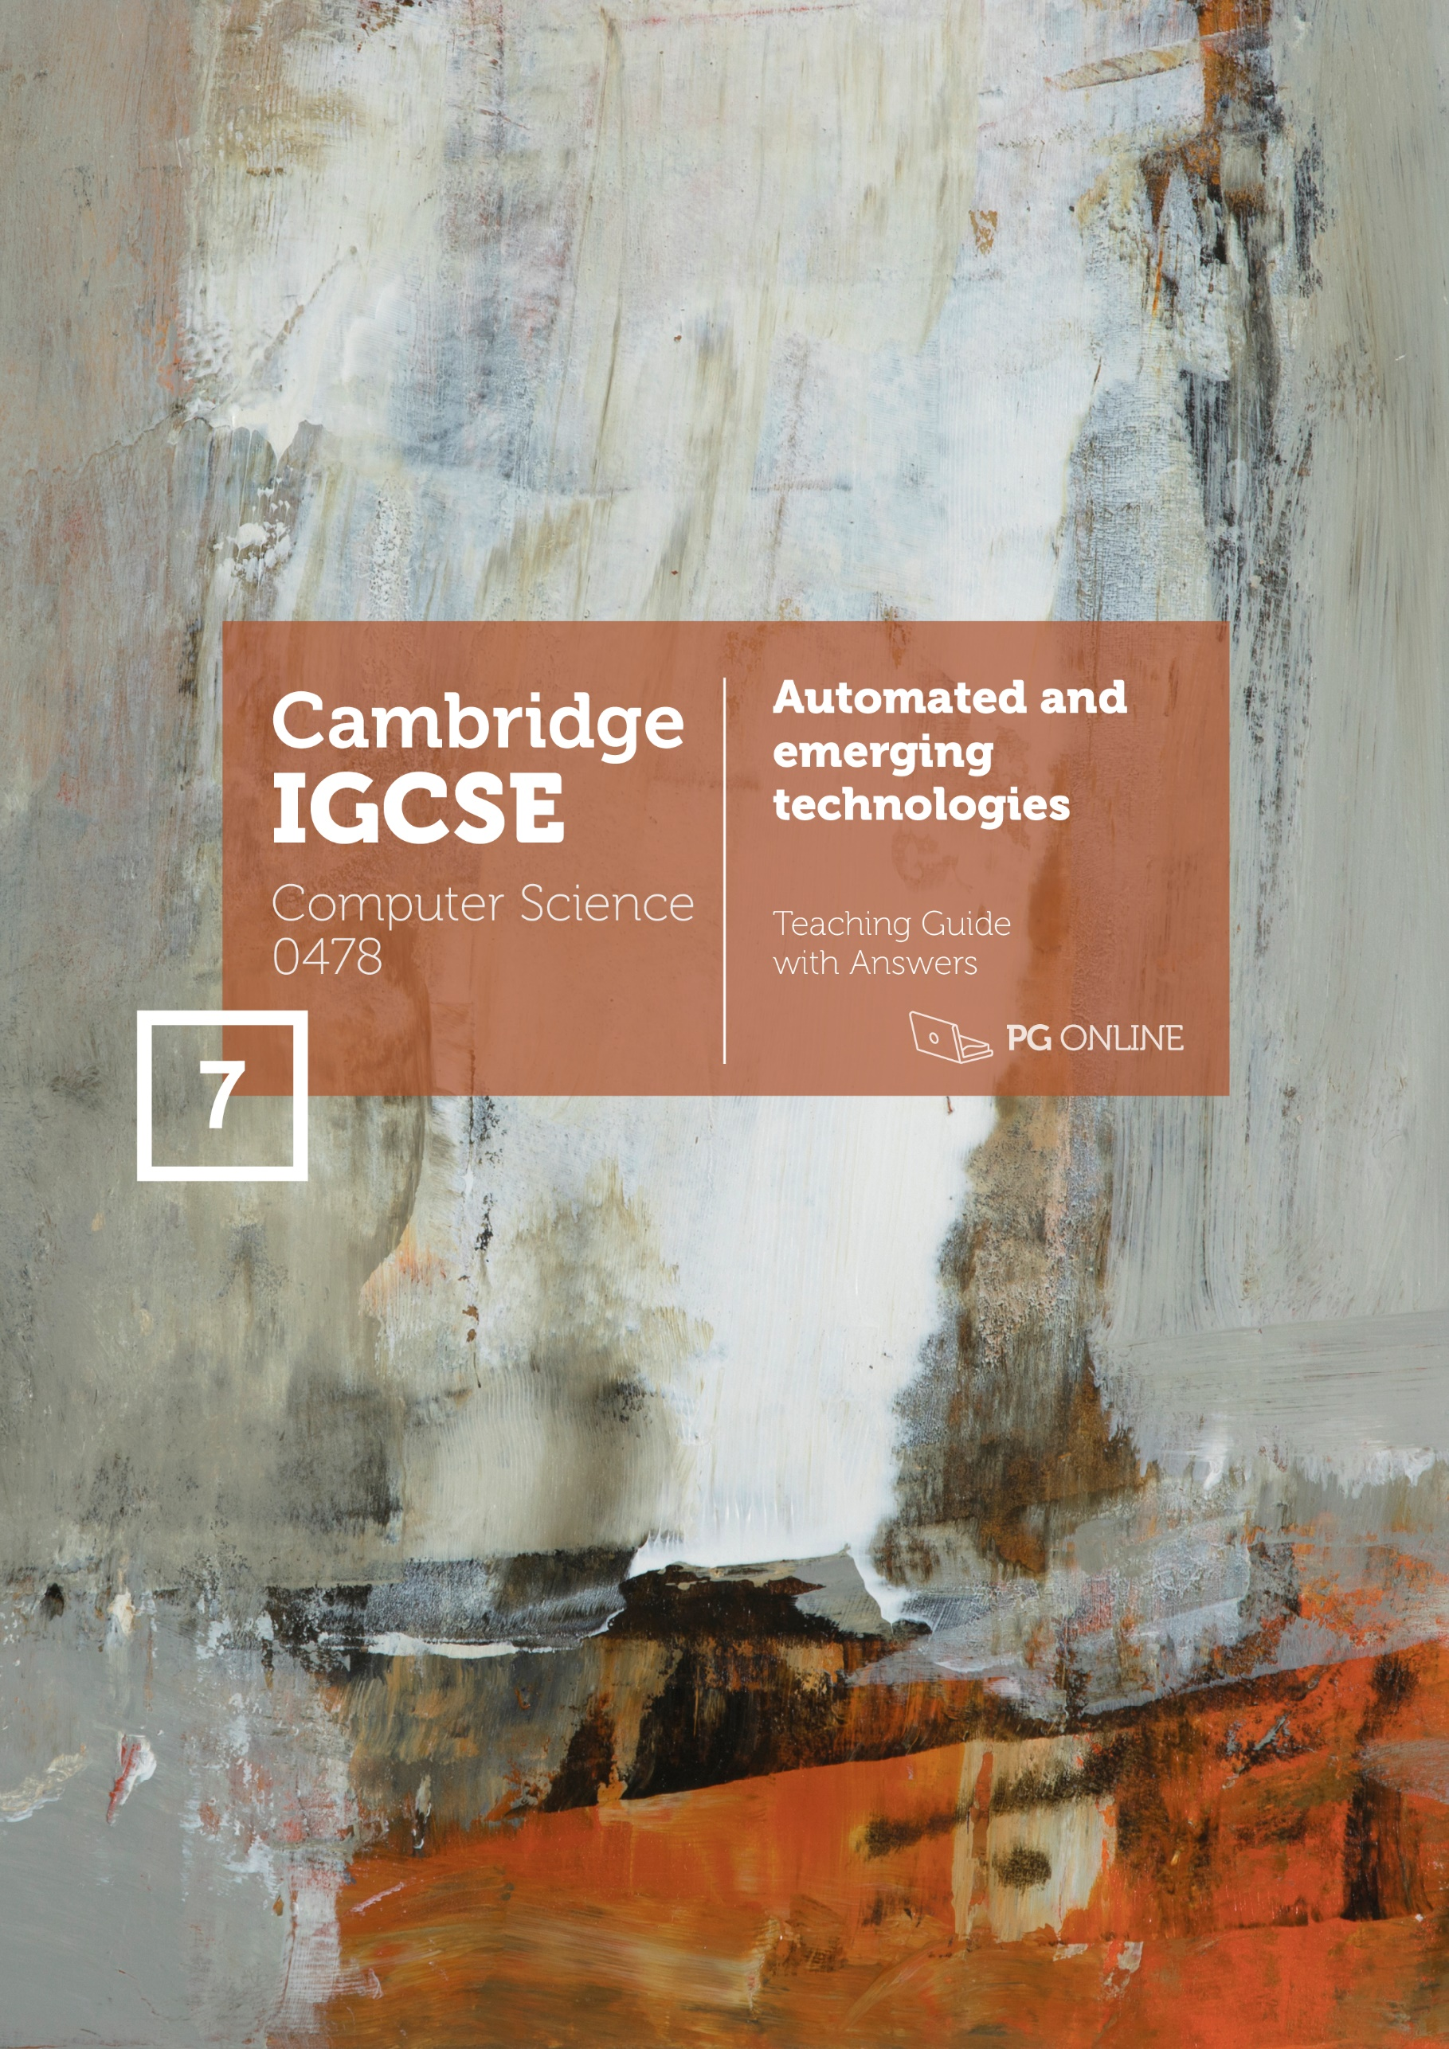
Copyright
© 2021 PG Online Limited
The contents of this unit are protected by copyright.
This unit and all the worksheets, PowerPoint presentations, teaching guides and other associated files distributed with it are supplied to you by PG Online Limited under licence and may be used and copied by you only in accordance with the terms of the licence agreement between you and PG Online Limited. Except as expressly permitted by the licence, no part of the materials distributed with this unit may be used, reproduced, stored in a retrieval system, or transmitted, in any form or by any means, electronic or otherwise, without the prior written permission of PG Online Limited.
Licence agreement
This is a legal agreement between you, the teaching institution, and PG Online Limited. PG Online Limited grants to you a non-exclusive, non-transferable, revocable licence to use this unit and all the worksheets, PowerPoint presentations, teaching guides and other associated files distributed with it in the course of teaching by your teachers and/or employees.
The materials distributed with this unit may be copied and used by your teachers and/or employees on a single site only in the course of their teaching. You warrant that you shall not, and shall procure that each of your teachers and/or employees shall not, share in any way any of the materials or part of the materials with any third party, including users on another site or individuals who are teachers and/or employees of a separate institution. You acknowledge and agree that the materials must remain with you, the teaching institution, and no part of the materials may be transferred to another institution. You also warrant that you shall not, and shall procure that each of your teachers and/or employees shall not, procure, authorise, encourage, facilitate or enable any third party to reproduce these materials in whole or in part without the prior permission of PG Online Limited.
In consideration of the licence granted to you, you shall indemnify PG Online Limited against all liabilities, costs, expenses, damages and losses (including but not limited to any direct, indirect or consequential losses, loss of profit, loss of reputation and all interest, penalties and legal costs and all other professional costs and expenses) suffered or incurred by PG Online Limited arising out of or in connection with the exercise by you of your rights granted under this licence.
Teacher’s Guide
Introduction
This teacher’s guide contains a detailed lesson plan to accompany the set of PowerPoint slides and worksheets for each topic.
The lesson plans are designed to form a basis for ideas for the teacher and should be adapted to suit the teaching style and preferences of the individual teacher, and the resources and nature of the individual school or Computer Science department.
The material supplied for this unit includes:
- 3 PowerPoint presentations, each designed to cover one topic, which may take more than one lesson
- 3 worksheets
- 3 homework sheets
- An end-of-unit test for assessment purposes
Summary
The unit is subdivided into three topics and an end-of-unit assessment. Each topic is designed to give enough materials for approximately 1 hour of teaching time, however, this will differ depending on how much depth is considered and whether homeworks are reviewed in the following lesson. The unit covers Section 6.3 of the Cambridge IGCSE Computer Science 0478 specification. Automated systems, artificial intelligence and robotics are all covered.
Vocabulary
Vocabulary associated with this unit, such as:
Sensors, microprocessors, actuators, automated systems, industry, transport, agriculture, weather, gaming, lighting, science, medicine, entertainment, robotics, domestic robots, drones, mechanical structure, framework, electrical components, programmable, artificial intelligence, AI, simulate, intelligent, rules, training data, expert systems, machine learning, knowledge base, rule base, inference engine, interface.
Assessment
Homework is given for each lesson. These consist of a mixture of short, factual questions assessing knowledge in isolation and longer questions in which students are asked to analyse a situation or justify their answer to questions.
The final assessment given assesses student’s knowledge of the current unit. In the actual examination, questions may integrate various topics into one question. As such, we strongly encourage teachers to use past papers and specimen papers to assess students and predict outcomes.

Learning Outcomes for the unit
At the end of this Learning Aim all students should be able to:
- Understand what robots are
- Understand the roles of robots in the following areas:
- Industry
- Transport
- Agriculture
- Medicine
- Domestic
- Entertainment
- Understand what is meant by artificial intelligence (AI)

Most students will be able to:
- Describe how sensors, microprocessors and actuators can be used in collaboration to create automated systems
- Describe the advantages and disadvantages of an automated system for a given scenario including:
- Industry
- Transport
- Agriculture
- Weather
- Gaming
- Lighting
- Science
- Describe the characteristics of robots
- Understand the roles that robots perform along with their advantages and disadvantages
- Describe the main characteristics of AI including:
- The collection of data and rules
- The ability to reason
- The ability to learn and adapt
Some students will be able to:
- Explain the basic operation and components of AI systems to simulate intelligent behaviour including:
- Expert systems
- Machine learning

Previous Learning
No prior knowledge is essential with this unit. However, students should have a basic understanding of computer systems from lessons delivered as part of the Key Stage 3 National Curriculum.
For this unit specifically, there is one unit on ‘AI and machine learning’. Whilst there is no expectation that students have studied this before, they will benefit from having studied the PG Online KS3 unit “AI and machine learning”.
This unit covers the question ‘What is AI?’ and machine learning, whilst going into further depth looking at the ethics of AI, image recognition, Turing tests and chatbots. Overall, this gives a solid and practical foundation to the AI topic required at GCSE.
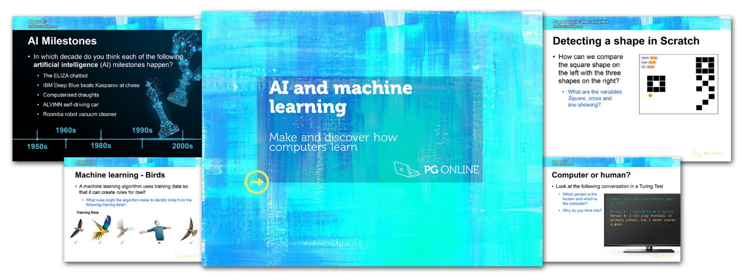

Suggested Resources
No specific software is required for this unit. It is primarily a theoretical unit that can be taught entirely without computers, but there are some exercises where computers could be used in order to support understanding through practical discovery.

Lesson plans
Topic 1 Automated systems
Objectives:
- Describe how sensors, microprocessors and actuators can be used in collaboration to create automated systems
- Describe the advantages and disadvantages of an automated system for a given scenario including:
  - Industry
  - Transport
  - Agriculture
  - Weather
  - Gaming
  - Lighting
  - Science
Content
Starter
PowerPoint Guide: Topic 1 Automated systems
The starter asks students to first consider an automated system (home alarm system) that they are likely to have a good knowledge of. This should allow them to consider a variety of sensors. In terms of the smoke detector, there are two ways that these can work. One method is to have a beam of light which will be reduced if smoke enters the device. An alternative method is to have a small amount of ionising radiation from a nuclear source. If smoke enters the device, it will change the amount of radiation that reaches the detector. This is why some detectors will have the radiation hazard (trefoil) symbol on them.
Make sure that students are aware that the siren is not a sensor but an output device. The key missing component is the keypad which contains a microprocessor (or microcontroller).
Main
Automated systems
Explain to students that automated systems require sensors, microprocessors and actuators in order to work and that they will need to know each of these terms.
Sensors
Students may already have met a number of sensors as these are also covered in section 3.2 of the specification. A variety are given here though by way of revision or in case this unit is taught first. If students are struggling to guess the purpose of the sensors, mention that they are all likely to be used in a car. This will help elicit which sensors might be used in cars before they consider specifically which have been shown here.

Microprocessors
Students will already most probably be aware of the concepts of CPU and RAM. Microprocessors are used in automated systems. As the processing required is likely to be small, they tend to use far cheaper microprocessors or microcontrollers. Explain to students that when a microcontroller is used, it will contain the RAM and ROM all in one unit. The program that an alarm system operates is very simple compared to a standard computer or smartphone. Microprocessors and microcontrollers are far cheaper, consume less energy and create less heat so don’t require fans to cool them.
Hand out Worksheet 1 and ask students to complete Task 1 and Task 2.
Topic 1 Worksheet 1
Topic 1 Worksheet 1 Answers
Transport
Transport systems make heavy use of automated systems. These may at first glance appear to be mundane, however, students should understand the benefits and how life was before these systems existed. Choose one of roads or railways and ask students to consider and explain all the automated systems within the method.
Show the video “How driverless trains work (Docklands Light Railway” [3m56s]
https://www.youtube.com/watch?v=a52ZSCIAoRk
Self-driving vehicles
Fully self-driving vehicles are far from common; however, they do exist and are being used in Phoenix, Arizona with the Waymo OneTM service. Waymo is owned by Alphabet Inc – the parent company of Google.
Ask students for other sensors that cars they have been in use and if any self-driving features are on them. At the most basic level, a car’s cruise control is an automated system which applies acceleration and brakes to maintain a steady speed. Most cars today have this feature.
Industry
The uses of automated systems in industry are too numerous to list. However, ask students what examples they may know of and discuss some additional ones. Show the video:
https://www.youtube.com/watch?v=zmqDIOrqWGQ&t=45s
Inside the Ferrero Rocher factory [0m45s-1m38s]
Highlight with students the sensors and actuators that are at work. Some features include conveyor belts, sensors, actuators, labelling machines and wrapping machines.
Also ask students to note how many people are involved in the process.
If students are interested in this video, show them the first part of this video which shows what happens at the start of the process in the factory:
https://www.youtube.com/watch?v=IVZhF3BUU80
Students can be given the opportunity to identify different sensors and actuators and even create simple algorithms that may be at work to control the machines.

Ask students to complete Task 3 on Worksheet 1.
Gaming
Show students the video:
https://www.youtube.com/watch?v=zmqDIOrqWGQ&t=45s
Upgrading my $40,000 Racing simulator. [8m46s-14m44s]
The whole video is very long, so start the video at 8m46s. The first part of the video, at this point, shows students a working simulator that is possible to install in a home. Ask students to identify the actuators and sensors in the system. Also ask students the advantages and disadvantages of using such as system – especially for a professional Formula 1 driver. The driver explains clearly the advantages for them in that it provides a more realistic experience. Cost would be the biggest disadvantage with space required being another issue. Take student through the Answers slide showing further advantages and disadvantages.
Ask students to complete Task 4 on Worksheet 1.
Plenary
Ask students the summary questions about automated systems and take them through the Answers that follow.
Hand out Homework 1.
Topic 1 Homework 1
Topic 1 Homework 1 Answers

Topic 2 Robotics
Objectives:
- Understand what robots are
- Describe the characteristics of robots
- Understand the roles that robots perform along with their advantages and disadvantages
- Understand the roles of robots in the following areas:
  - Industry
  - Transport
  - Agriculture
  - Medicine
  - Domestic
  - Entertainment
Content
Starter
PowerPoint Guide: Topic 2 Robotics
Ask students what areas robots are used in today. The areas given on the Answers slide are those that they are expected to know on the specification. Students may give other areas which is acceptable. Ask students to give one or two specific examples of the use of robots.
Main
Robotics and characteristics
Go through the definition of robotics given on the slide and ask students for the characteristics that robots have. Students may give specific characteristics, such as ‘have something that rotates’. Ask them if they are able to think of counter examples until they are able to reach the more general characteristics which are given on the Answers slide.
Electrical components
The robot shown is a NAO robot. It has very lifelike motion with joints based on areas where human joint and rotation are positioned. Students may have seen this robot in real life, however an example of its fluid motion and some of the sensors it has can be seen in the following video:
https://www.youtube.com/watch?v=2STTNYNF4lk
Nao Robot [2m52s]

Programmable
Explain to students that robots are programmable. This means that the way they operate can be changed. They are typically programmed via a keypad, handheld device or another computer.
As students are likely to have less knowledge of an industrial robot, show them the video:
https://www.youtube.com/watch?v=7coUcEHxnYA
How 6-Axis industrial robots work. [0m0s-2m13s]
This video shows the programming of a Fanuc robot using a handheld device.
If students are interested in such programming, they may also like to watch the second video:
https://www.youtube.com/watch?v=9Iz4oPPLKzM
Programming Fanuc robots [0m0s-1m50s]
This shows how robots can be programmed in a 3D environment before they are shipped to the customer.
Hand out Worksheet 2 and ask students to complete Task 1 and Task 2.
Roles robots perform
Ask students to consider again the roles that robots perform. Each of the main areas in the specification are then covered in the following slides.
Industry
Take students through the information on the slide. To give more realism to industry robots, show students how a Fanuc robot is used in the manufacture of an Audi car.
https://www.youtube.com/watch?v=rbki4HR41-4
FANUC Industrial Robots at AUDI [0m0s-2m08s]
Agriculture
There are many uses for robots in agriculture. Tractors can be driven to use GPS to follow a path set by the farmer. Production lines will use conveyors and various actuators to assist in packaging food. Ask students to consider how a robot strawberry picker could work. In solving this, ask them first to consider the use of colour to establish ripeness and the actuators that would be required to move to the correct position, make a cut and hold the strawberry. Show the video:
https://www.youtube.com/watch?v=FCivsotZEjk
Meet the robotic strawberry harvesters. [0m0s-1m04s]
This shows strawberries being picked by robots based on the colour and ripeness.
Transport
Take students through the slide and remind them of the previous video they saw on the Docklands Light Railway. This time show the video:
https://www.youtube.com/watch?v=TZaIk8jsSNs [0m0s-2m19s]
Self-driving Thameslink trains
This video shows some of the advantages (extra capacity) and disadvantages (the potential for a faceless service) of such systems.
Domestic robots
Go through the slide and show two uses of domestic robots with the two examples given. Ask students what advantages and disadvantages they see in these robots.
Robots in entertainment
Take students through the information on the slide. You may wish to also show them a video of the latest Aibo version.
https://www.youtube.com/watch?v=8t8fyiiQVZ0
The $3000 Sony Aibo Robot Dog. [0m0s-6m58s]
The video shows some of the sensors that the robot contains such as a camera sensor in the nose, camera sensor on the top for spatial awareness and other sensors to detect stroking. Actuators control the legs and movement.
Ask students to complete Task 3 on Worksheet 2.
Agriculture
It is important that students have an awareness of the advantages and disadvantages of robots. Ask them to consider these for a robot of their choice. Then go through the Answers slides to see how many of their answers match the generic ones given.
Ask students to complete Task 4 on Worksheet 2.
Plenary
Take students through the two summary questions on the slide and then go through the Answers slide that follows.
Hand out Homework 2.
Topic 2 Homework 2
Topic 2 Homework 2 Answers

Topic 3 Artificial intelligence
Objectives:
- Understand what is meant by artificial intelligence (AI)
- Describe the main characteristics of AI including:
- The collection of data and rules
- The ability to reason
- The ability to learn and adapt
- Explain the basic operation and components of AI systems to simulate intelligent behaviour including:
- Expert systems
- Machine learning
Content
Starter
PowerPoint Guide: Topic 3 Artificial intelligence
The starter appears to be a simple question, but it is actually quite difficult to define intelligence. It is suggested that students work in a pair or small group for this question as they may all have different ideas. Go through the Answers slide that contains some suggestions.
Main
Artificial intelligence
Go through the definition of AI given in the slide and ask students to think of examples where AI is used.
You may wish to play the following video which explains AI. Some of the topics are slightly more advanced and outside the scope of the specification, but this may be of interest to more able students to give an overview of the topic.
https://www.youtube.com/watch?v=2ePf9rue1Ao
What is Artificial Intelligence? [5m27s]
Characteristics of AI
This slide shows a set of characteristics of AI that are given in the specification. Ask students to consider what each of them mean and what computers have to achieve to be considered ‘intelligent’.
Rules
One key area of building an AI system is that it needs to have a set of rules. The program may build these rules for itself, as in a machine learning system, or these rules can be pre-programmed, as in an expert system.
Ask the students to create their own rules to distinguish between a happy and sad face, then compare their answers with those given in the Answers slide.
Reasoning
Reasoning (logic) is also required within an AI system. Go through the deductive reasoning example shown that uses logical reasoning to make a deduction.
Hand out Worksheet 3 and ask students to complete Task 1, and Task 2.
Topic 3 Worksheet 3
Expert systems
Expert systems simulate a human expert. Generally they are used in relatively simple AI systems, however, you could see how a similar system could be used to make a diagnosis from symptoms. Students may be aware of the UK’s 111 medical help line. This helpline is for urgent medical problems, but not life-threatening emergencies. On the 111 system, the first call handler will use an expert system to give advice or call an ambulance. Some conditions require more knowledge than the computer program can tell, in which case an experienced human will call the patient back.
Make sure students understand the four different components of an expert system that are covered on the following slides.
Knowledge base and rule base
Databases store data. In a similar way, a knowledge base stores facts and a rule base stores rules on how these facts can be used. Students can think of IF-THEN type statements as a way of storing rules.
Inference engine
The inference engine makes use of the rule base and knowledge base to deduce conclusions to questions. Although forward chaining and backward chaining are not specifically mentioned in the specification, they are relevant to understanding how an inference engine can derive the answers to questions.
Interface
The interface is the method in which the user interacts with the computer program. Students are likely to have encountered chat bots for help systems or telephone expert systems that require yes/no answers or numbers on the telephone to be pressed. Ask them to discuss their experiences with a partner and how it compared to interacting with a human. Which did they prefer? What are the advantages and disadvantages?
Ask students to complete Task 3 on Worksheet 3.
Machine learning
Go through the slide then show students the video:
https://www.youtube.com/watch?v=3bJ7RChxMWQ
Machine learning explained in 5 minutes [5m14s]
Detecting fish or chips
Ask students to consider the properties that could be used to detect fish and chips. This may seem obvious, but some properties are more important than others. Quantity and size are very important, with colour and texture also being important.

Machine learning meals and rules
The slides show a series of properties and the training data that could be given to a machine learning program. Ask students to establish any patterns that they can see in the data and take them through the Answer slides that follow. Remind them that the program would be establishing these rules and pattern in real life, which is why the technique is known as machine learning.
Ask students to complete Task 3 on Worksheet 3.
Plenary
This lesson has quickly gone through the field of AI along with two the two key areas that students need to be aware of (expert systems and machine learning). Ask students to consider the text in pairs and fill in the gaps with the given words.
If time permits, ask students how machine learning, expert systems and AI could be used in the future.
Hand out Homework 3.
Topic 3 Homework 3
Topic 3 Homework 3 Answers

Final assessment
Learning Outcomes:
Students will
- apply their knowledge in answers to a range of questions
- be able to identify areas of strength and any gaps in their understanding of impacts of digital technology on wider society

Content
Students should complete the Assessment Test.
Unit 7 Assessment Test.docx
Unit 7 Assessment Test Answers.docx
The test has been designed to be printed and answered by hand.

Acknowledgements
The authors and publisher would like to thank all contributors for their kind permission to reproduce their photographs or images, screenshots of their websites or other copyright material in the PowerPoint Guides.
Photographic images copyright © Shutterstock
Smoke detector image: urbanbuzz / Shutterstock.com
Tyre image: RTimages / Shutterstock.com
Ford Ecsort image: Joseph M. Arseneau / Shutterstock.com
Self-delivery vehicles: David Cardinez / Shutterstock.com
Programmable robot image: AlesiaKan / Shutterstock.com
Robot bus image: SariMe / Shutterstock.com
Nao Robot images: DeymosHR / Shutterstock.com
Robot dog: Londisland / Shutterstock.com
Diagrams and illustrations © PG Online
Every effort has been made to trace the copyright holders and we apologise in advance for any unintentional omissions. We would be pleased to insert the appropriate acknowledgement in any subsequent edition of this publication.
This material contains links to relevant websites featured in the teacher’s guide. Every effort has been made to ensure that at the time of distribution, the links remain unbroken, the material remains up-to-date and that links are not inadvertently linked to sites that could be considered offensive. PG Online cannot be held responsible for the content of any website mentioned in this material. It is sometimes possible to find relocated sites by typing the original URL into a browser. Any errors should be reported directly to support@pgonline.co.uk and changes will be made in any subsequent editions of the material.

Artwork

Edge
© 2018 Neil Canning
MM/paper 21 cm × 29.5 cm
www.neilcanning.com/

